OS SKILL
SKILL-7
Process Synchronization and Child Process Monitoring Using waitpid().
To Retrieve PATH Variable, Parse Search Directories, Locate Executables, Verify Permissions, Handle Missing Commands, Test Command Resolution.

waitpid_demo.c

#include <stdio.h>
#include <stdlib.h>
#include <unistd.h>
#include <sys/wait.h>
int main() {
pid_t pid;
int status;
printf("Parent process started. PID = %d\n", getpid());
pid = fork();
if (pid < 0) {
perror("fork failed");
return 1;
}
if (pid == 0) {
printf("Child process started. PID = %d\n", getpid());
for (int i = 1; i <= 5; i++) {
printf("Child working: %d\n", i);
sleep(1);
}
printf("Child process completed.\n");
exit(5);
} else {
printf("Parent waiting for child...\n");
pid_t result = waitpid(pid, &status, 0);
if (result == -1) {
perror("waitpid failed");
return 1;
}
if (WIFEXITED(status)) {
printf("Child exited with status: %d\n",
WEXITSTATUS(status));
}
printf("Parent process resumed after child completion.\n");
}
return 0;
}

OUTPUT
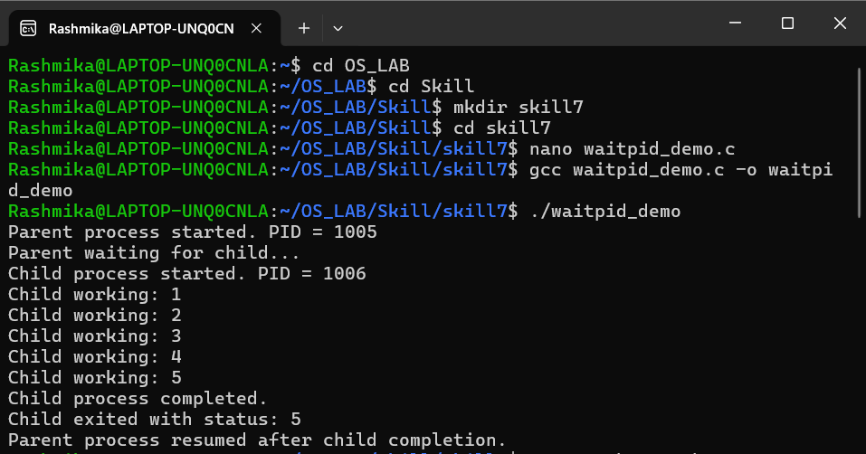

path_search.c

#include <stdio.h>
#include <stdlib.h>
#include <string.h>
#include <unistd.h>
#include <sys/stat.h>
#include <limits.h>

int main(int argc, char *argv[]) {
char *path;
char *copy;
char *dir;
char fullpath[PATH_MAX];
struct stat info;
int found = 0;

if (argc != 2) {
printf("Usage: %s <command>\n", argv[0]);
return 1;
}

path = getenv("PATH");

if (path == NULL) {
printf("PATH variable is not set.\n");
return 1;
}

printf("PATH = %s\n", path);

copy = malloc(strlen(path) + 1);

if (copy == NULL) {
perror("malloc failed");
return 1;
}

strcpy(copy, path);

printf("\nSearching for command: %s\n", argv[1]);

dir = strtok(copy, ":");

while (dir != NULL) {
printf("Checking directory: %s\n", dir);

if (snprintf(fullpath, sizeof(fullpath),
"%s/%s", dir, argv[1])
>= (int)sizeof(fullpath)) {
dir = strtok(NULL, ":");
continue;
}

if (stat(fullpath, &info) == 0 &&
S_ISREG(info.st_mode) &&
access(fullpath, X_OK) == 0) {

printf("Executable found: %s\n", fullpath);
found = 1;
}

dir = strtok(NULL, ":");
}

if (!found) {
printf("Command not found or not executable: %s\n",
argv[1]);
}

free(copy);
return found ? 0 : 1;
}
OUTPUT
